BY: Maxwell Carter

Hi, this basic tutorial will teach you how to create a simple button, which can be found in almost every app.

Once we are finished feel free to create your own designs and take you button making abilities to the next level by using Photoshop.

Step1. First you must decide what type of design your button will have. Just for this example I have chosen to use a brick background from google…

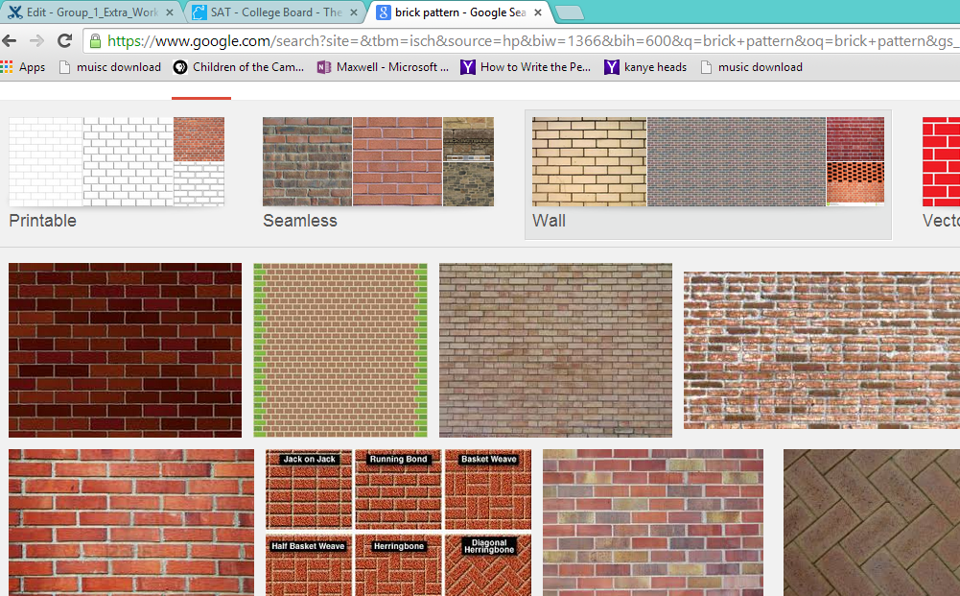

Step2. After choosing the background you have selected either save it to the desktop or somewhere easy to remember. Also make sure you don’t forget about copy right and stealing other people’s designs. In this next step we will now open the picture in Photoshop.

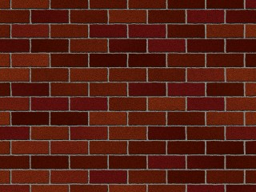

Above is the picture I have chosen.

Step3. Now in order to cut out the button shape there are a variety of methods. To keep things efficient you can either select the rectangle selection button or select the pen tool to draw out your button manually.

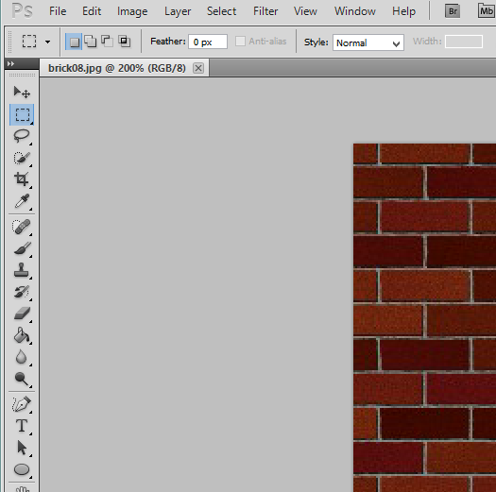

Step4. After cutting out your button you can now write on it simply by selecting the T icon on the lower left side. Seen here in the image above.

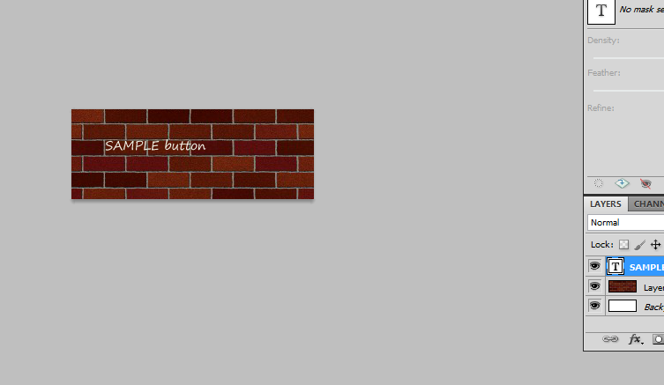

Step5. Now that we have written some words on our button we can now edit it to make it look more realistic instead of just a rectangle.

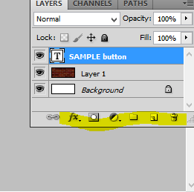

Step6. Finally by going down to the right side of the screen where it is highlighted we are provided with a variety of image editing tools that will allow us to customize our very own buttons.

Hopefully this short simple guide has helped you , thank you!